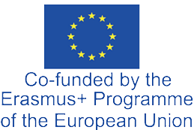

Assocation my Mobility

Str 142, Nr 41, Tetovo, 1200, North Macedonia
+38970649694
vila_80@yahoo.com

Association myMobility, Tetovo, North Macedonia is happy to invite the following teachers Podstawowa Nr 10z Oddzialami Integracyjnymi im. Waleriana Lukasinskiego w Zamosciuparticipate Zamosc, Poland in the 1-st Transactional Meeting of Cooperation Partnerships in School Education project in Tetovo, North Macedonia
15/01/2025-18/01/2025

We are looking forward to welcoming them to Tetovo, North Macedonia

Teachers:
- Iryna Pylypak,
- Bożena Czochrowska-Pisarczyk,

Founder/Director my Mobiliy Tetovo, North Macedonia
Arben Vila 12/11/2024
