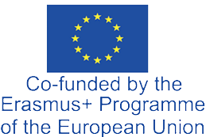

Assocation my Mobility

Str 142, Nr 41, Tetovo, 1200, North Macedonia
+38970649694
vila_80@yahoo.com

Association myMobility Tetovo, North Macedonia is happy to invite the following teachers LYCEE DES METIERS VUE BELLE France Réunion SAINT PAUL participate in the 1-st Transactional Meeting of Cooperation Partnerships in School Education “ Acces4All Transforming Education through Digital Inclusion between the dates:
15/01/2025-18/01/2025

We are looking forward to welcoming them to Tetovo, North Macedonia

Teachers:
- Sabine MONTROUGE
- Sandrıne CHABRIAT

Founder/Director my Mobiliy Tetovo, North Macedonia
Arben Vila 12/11/2024
